**React Native App**

**Dependencies**

React-Native-paper (Searchbar, Card)

styled components for RN (styled)

**Status Bar**

For IOS we use the Expo StatusBar and we must set it at the bottom of the App.

import { StatusBar as ExpoStatusBar } from "expo-status-bar";

<ExpoStatusBar style="auto" />

For Android we use Platform and StatusBar

import { StatusBar, Platform,} from "react-native";

// ANDROID

const isAndroid = Platform.OS === "android";

// Style:

marginTop: isAndroid ? StatusBar.currentHeight : 0,

**Design System**

To keep consistency in our App. Inside SRC create INFRASTRUCTURE - THEME. On this Theme folder add Fonts, Colors, Sizes, Spacing and Index.js

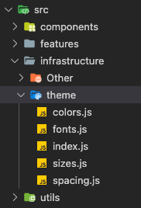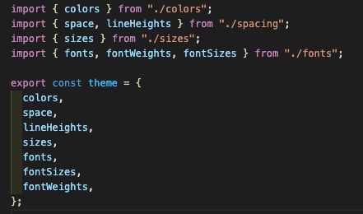

Example with Fonts:

We need to Install Expo Font & Expo Google Fonts/fontName

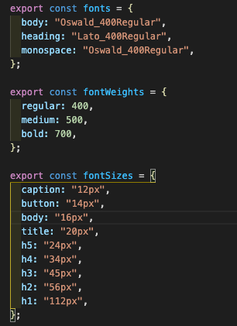

In APP:

import {useFonts as useOswald, Oswald_400Regular} from "@expo-google-fonts/oswald";

import { useFonts as useLato, Lato_400Regular } from "@expo-google-fonts/lato";

export default function App() {

// Loading Fonts

const [oswaldLoaded] = useOswald({

Oswald_400Regular,

});

const [latoLoaded] = useLato({

Lato_400Regular,

});

if (!oswaldLoaded || !latoLoaded) {

return null;

}

// Main Return:

return ();

}